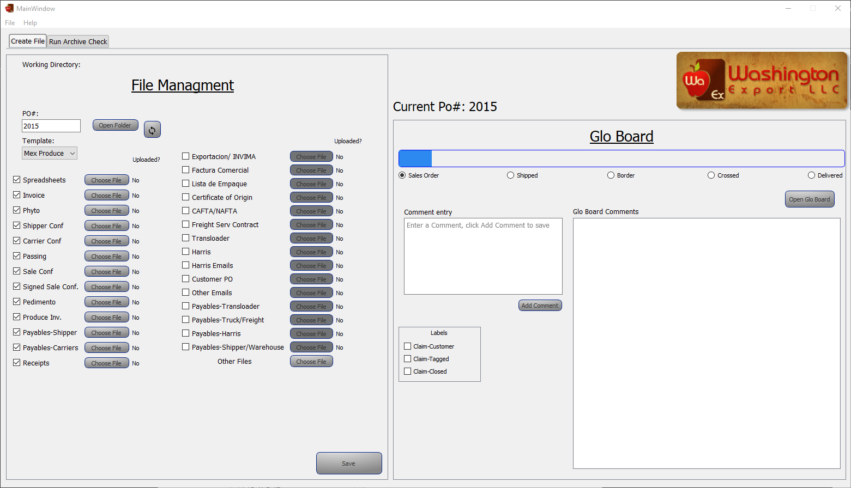**WAEX Filing Program-Using Glo Board**

Open Glo Board in browser

View and change postition

Add comments, click “Add Comment” to save

View and change current lables

View comments